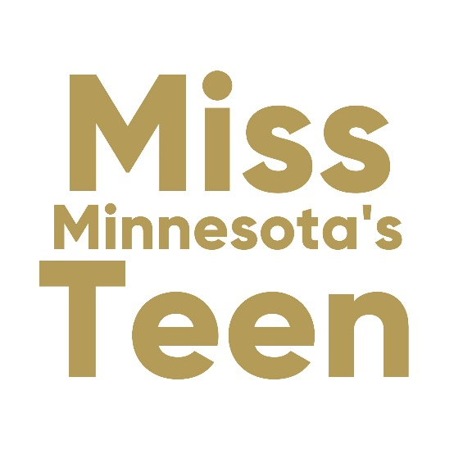

Talent Production Form
ORIGINAL WORKS or MATERIAL TALENTS: Candidates who presents a talent that involves her own original work; i.e., a painting, music arrangement, song writing, authorship of a dramatic reading, etc., must give MMSO notarized authentication that she created the work in order for it to be approved for the competition.

PUBLISHED LITERARY MATERIAL TALENTS: Talent presentations involving the reading of literary works, theatrical scripts, or scenes from a movie, require the Candidate to research and contact the author and/or publisher for a written “Permission Letter.” MMSO’s production team does not research clearance for literary works. These letters should indicate that we have the owner’s permission to use the material on-stage. Dramatic performances cannot include scenes that mimic a play, including costume.

TALENTS USING MUSIC ACCOMPANIMENT: If you are using a music track to accompany your talent, the song must be covered under the license agreements of BMI/ASCAP/SESAC or be considered Public Domain. Therefore, the Miss Minnesota Scholarship Organization (MMSO) needs to approve each candidate’s talent music selection. We have an agreement to use only music licensed through BMI, ASCAP or SESAC. Once you complete the Talent Reservation Form and have provided us with the song title and composer, we will verify its license information for you and let you know within 3 business days if your song is cleared.

Lyrics, Dialogue and Backup Lyrics on Accompaniment Track: Whether you are singing, dancing, conducting a science experiment, playing an instrument, or speaking, etc., and using an accompaniment track, we need you to submit one (1) copy of your lyrics, backup lyrics and/or dialogueEvery word must be included no matter how little. Lyric changes cannot be changed for any licensed song.

MUSIC TRACKS: Once your music track is approved and you have your :90 talent track ready, before you submit it for the state competition, candidates must listen to and approve the accompaniment track before it is sent to MMSO. This will prevent situations where the wrong track is sent and not realized until we are at Competition.

UPLOADING YOUR MUSIC: Candidates are to upload talent accompaniment tracks on the Miss Minnesota website. This is the only accompaniment you will be authorized to use for the Competition. Our production team will verify that they can download the music onto their equipment. If there are any problems with the music track, the Local Director, Parent, Guardian and/or the Candidate will be notified and a new track may be required. Once a Talent track is accepted and approved no changes or substitutions can be made.

**ALL UPLOADED MUSIC TRACKS MUST BE LABELED WITH THE FOLLOWING INFORMATION: Contestant Name, Title, Track title
For example, if Cindy Smith, Miss Roseville’s Teen is dancing to Baby Shark, her track will be labeled like this: ROSEVILLE Cindy Smith BABY SHARK.mp3

TALENT TIME REMINDER: The time limit for talent presentation is ninety (90) seconds. If your track exceeds this time limit, it will be returned and a new one must be produced. Do not plan a performance that exceeds the ninety-second-time limit. Judges are informed if a Candidate runs over her time limit and this information is used to determine the Candidate’s score.

ACCOMPANYING ONESELF with a Pre-Recorded Track: Candidates may pre-record herself as a backup vocalist or instrumental accompanist and use that track to accompany her live talent performance. However, it cannot be announced to the judges that the accompaniment track contains any performance by the Candidate. Candidates are judged solely on what they are performing live, no exceptions. A talent cannot be performed electronically (i.e., video tape) or with live accompaniment.

TRACK ENHANCEMENTS: regardless of the talent performed, the background track cannot have voices, instruments or other noises that mimic the talent of the Candidate. Example: a vocalist may have background vocals with “oohs and aahs” but cannot have a track containing any background lyrics or a voice singing the melody line for the Candidate to sing along. This also includes instrumentalists, dancers and any other talent as it could provide an unfair advantage if judges cannot delineate from the “live” performance and the talent track.

DOUBLE TALENTS: Candidates are only judged on what is performed “live.” If a Candidate wishes to perform a double talent, for example, singing and dancing, or singing and piano playing, she must perform both live on-stage. However, if a Candidate dances to a pre-recorded track of her singing, she is only judged on her dance and it is not announced that she is singing on the track.

MEDLEY: Each song in a medley requires authorization by MMSO.

Talent Rehearsal Conference Consent:
FILL IN NAME AND CELL # WHERE DESIGNATED AT THE BOTTOM OF THIS PAGE
You will meet with your designated “Talent Advocate” during the morning talent tech rehearsals at Miss Minnesota’s Teen Competition (MMNT) – date and time to be announced. You may appoint one person who will meet with you. This can be your local director, your talent coach, or family member. This authorization must be discussed with your local director (if you have one).

PROPS USE AND RESTRICTIONS: no props will be permitted unless they are absolutely functional. The following props are not allowed:
- No mood setters or background enhancers, No lighting enhancements
- No props that imitate those used in a Broadway or screen version of the selected talent
- No props that require excessive stage area and/or complicated setup
- No use of motion pictures, slides or projection of any kind
- No live animals
- No gymnastics floor mats; unless approved
- No props involving safety hazards, such as any form of liquids or fire; or props that could create sparks, along with swords, knives, bow and arrows, sharp projectiles, etc.
If you are unsure if a prop meets the proper standards, or if you should have any production questions, please contact the Miss Minnesota State Competition Executive Director.
Delivering Props: Large and bulky props that cannot be carried in with candidate, must arrive at the SW Christian High School theater loading dock location during check in. Props must be properly packaged and labeled with Candidate name. All props MUST be removed immediately following the Competition, or they will be discarded.

Detailed Talent Music Information
Candidate Name (How you would like your name announced on stage)

Candidate Local Title

Talent Type

TALENT DESCRIPTION – Please make a complete description of your talent act – be specific

TALENT INTRO – this will be read on stage as you enter for talent. Limit to 3 sentences.
Full title & artist of approved music used for your talent.

Composer(s)

Publisher(s)

I understand my talent presentation cannot exceed 90 Seconds. ( ) NO ( ) YES

I have accurately timed my talent presentation at: ______________Seconds

Accompaniment Track for my Talent Presentation ( ) NO I am not using a track
( ) YES I am using a track

I have listened to and approve my Music Track ( ) NO ( ) YES

If you have produced your own music track, please provide the name, address, and phone number of the arranger or producer for your talent track. The original master recording is permitted for use without any alteration. Please attach a signed release by the Producer/Composer and any musicians who performed on the music track.

Producer/Composer Name
Address
City, State, Zip
Phone
Email

My accompaniment track is: (check one)
( ) Edited Master ( ) Karaoke Version ( ) Custom Recording

Please check appropriate boxes:
My lyrics are ( ) Enclosed ( ) N/A
Back up lyrics are: ( ) Enclosed ( ) N/A
My Reading is: ( ) Enclosed ( ) N/A
If you are performing a reading, list the book, play, etc., for which you have obtained clearance.

LYRICS (please list out below)

Please describe your talent costume: Color, fabric, beading, etc.

My Talent Presentation will require props. I have read the ‘props’ information and understand the restrictions and drop off/pick up times. ( ) NO ( ) YES

What type of microphone do you need?
( )NO MIC NEEDED ( )Stand ( )Hand Held ( )Head Set
I have uploaded my talent track to the website ( ) NO ( ) YES
TALENT ADVOCATE
Your designated Talent Advocate must be at the morning tech rehearsal at the venue to meet with you. Times will be provided after Orientation. You are allowed up to 4 people to attend the rehearsal. ONLY ONE may speak with you during this time. If your Talent Advocate is not in the theater when your rehearsal starts, a member of the Miss MN Tech Team will be the advocate.
NO RECORDING OF TALENTS ALLOWED during rehearsals.

I certify that all the above information is correct with respect to the 2023 Miss Minnesota’s Teen Talent information.

______________________________________________________________________________
Candidate Signature Date

______________________________________________________________________________
Local Director Signature (or Parent/Guardian if no local director) Date

