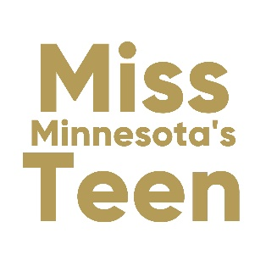

State TEEN Resume Instructions

Due Date: UPLOAD to website by Feb 25, 2023
Bring 10 Copies to Orientation on March 3, 2023
This is your opportunity to demonstrate to the state judges why they should consider you for the job of Miss Minnesota’s Teen. Your RESUME, combined with the Social Impact Initiative Statement will comprise your entire application for this job. The judges will receive exactly what is submitted.
Instructions for Candidate's Resume
- Resume can be one (1) page only
- Leave a one-half inch (1/2”) margin on all sides of the resume
- In the style/format Candidate feels best reflects interviewing for the job of Miss Minnesota’s Outstanding Teen 2022
- Color can be used on your resume
- You can use ONE photo on your resume. It does not have to be your official headshot.
- Print on white paper. You can use Presentation paper, but No heavy card stock.
- Use any style font – but nothing less than 10-point
- The following MUST be included on your resume:
Name – Social Impact Initiative Title – School attending – Talent - Date of Birth
State Instructions: Place 10 copies each of Resume & Social Impact Initiative in one envelope with metal clasp. Label with your name and title on the outside of envelope. Bring to Orientation, March 3.
Copies of both your Resume & Social Impact Statement must also be uploaded to the Miss Minnesota website under State Teen Paperwork, no later than February 25, 2022.

The following are only suggestions and ideas for your resume.

Create a Resume that best reflects who you are, your accomplishments and qualifications to successfully fulfill the duties of the role of Miss Minnesota’s Teen. The following ideas do not have to appear in this order or even be used. Again, these are ONLY suggestions.

Required items on your Resume: Name, Talent, Social Impact Initiative, School attending & date of birth.

Suggestions Include:
- Highest Educational Standing
- Major/Minor you hope to declare in college
- Scholastic Achievements/Honors Leadership roles in High School
- General Goal or Objective in competing as it relates to becoming Miss Minnesota’s Outstanding Teen or as it relates to Career Ambitions
- Activities/Accomplishments
- Skill Sets: leadership, strong communications skills, motivational speaker, strong organizational skills, fundraising, social media, bi-lingual
- Interests: traveling, scrapbooking, yoga, white water rafting, etc.
- Anything interesting facts that relate to your abilities to carry out the duties of Miss Minnesota’s Outstanding Teen.
- Be creative – sell yourself – be honest – don’t embellish

For creative and colorful template ideas for your Resume, go to design websites like canva.com and search RESUMES.

IN REVIEW:
Submit the document as a PDF and label it: TITLE, NAME, SOCIAL IMPACT STATEMENT.
For example, Cute Dog is Miss Minnesota’s OT, her file would be labeled:
MINNESOTA OT Cute Dog SOCIAL IMPACT STATEMENT

